Modeling the School Entry Policy

Name/s: Dawn Andrei Pamesa | Section: TS31
Purpose. A model is a simplified representation of a real system. In this homework, you will examine the school’s new entry policy and create a small conceptual model showing how a person is permitted to enter, directed to complete an additional requirement, or denied entry.
Use the Class Attendance example as a guide. Identify the corresponding elements of the entry-policy system, but do not copy the attendance answers because the two systems have different entities, attributes, activities, decisions, and outputs.

Learning Outcomes
- Identify the entities, attributes, inputs, activities, decisions, outputs, and boundary of a real school system.
- Construct a clear conceptual model of the school entry process.
- Classify and evaluate the model using introductory modeling concepts.
- Explain the assumptions and limitations created when the real policy is simplified.

Assessment Classification
AI Assisted. AI may support limited parts of the work, but you remain responsible for observing or reviewing the actual policy, selecting the model elements, deciding the flowchart logic, verifying every condition, and writing the final explanations.

AI Use Rules

Permitted AI Support | Not Permitted
Ask for explanations of terms such as entity, attribute, system boundary, discrete, deterministic, and stochastic. | Ask AI to produce the entire submission and submit it without independent analysis.
Brainstorm possible model elements after you have reviewed the official policy. | Allow AI to invent, assume, or replace conditions that are not stated in the official policy.
Request feedback on the clarity or logic of your completed draft flowchart. | Copy an AI-generated flowchart or explanation that you cannot justify during class.
Improve grammar and organization without changing your meaning. | Enter names, identification numbers, photographs, security details, or other private information into an AI tool.

Instructions
- Review the official school new entry policy and identify where the entry process begins and ends.
- Trace the process from a person’s arrival until the person is permitted to enter, directed to complete another requirement, or denied entry.

- Complete the model-elements table in Part A using concise but specific descriptions.
- Create the flowchart required in Part B. Base every activity and decision on the actual policy.
- Answer the analysis questions in Part C using your own reasoning.
- Complete the AI Use Declaration and compile all requirements into one PDF file.

Part A - Identify the Model Elements
Complete the table based on your understanding of the official entry policy.

Element | Guide Question | Your Description
System | What real-world process are you modeling? | Entry of a person at the FEU Tech gate, from arrival until they are admitted, admitted with a violation stub, or denied entry.
Entity or Entities | Who or what participates in or moves through the system? | The person seeking entry: student, instructor, employee, associate, or outsider. Security guards, the ID kiosk and the visitor system are resources that serve the entity, not entities, because they operate the process rather than move through it.
Attributes | What characteristics or information about an entity affect the entry decision? | Role (insider or outsider); whether the FEU ID and FEU lace are worn; dress-code compliance (covered footwear, no sandals, no shorts outside the permitted warm-season months, nothing revealing); possession of contraband; possession of equipment requiring a permit; sobriety.
Inputs | What information, documents, or initial conditions are required? | FEU-issued ID with FEU lace; stated purpose of visit and an approved request (outsiders); visitor pass issued at the information booth; permit from the respective office for equipment not normally allowed on the premises.
Activities | What actions are performed while implementing the entry policy? | Insider path: queue at the ID kiosk, tap the FEU ID, queue at the security booth, place the bag for a thorough search, undergo the metal-detector sweep, proceed inside. Outsider path: go to the information booth and state the purpose of visit, register at the visitor system kiosk, return for a visitor pass, then join the same search and sweep. Violation handling: issue a violation stub and record it in the handbook, have it signed at the respective office, and return it before exiting.
Decision Conditions | What conditions determine which path the entity follows? | - Is the person an insider (FEU ID holder) or an outsider?  - Is the ID FEU-issued and worn with the FEU lace?  - Is the prescribed dress code followed?  - For outsiders, was a visitor pass properly requested and granted?  - Does the bag search find contraband, or equipment that requires a permit without one?  - Does the metal-detector sweep come back clear, and is the person not visibly intoxicated?
Outputs | What are the possible results of the entry process? | - Standard entry: all conditions satisfied and the person proceeds inside.  - Entry with a violation: a stub is issued and recorded in the handbook, signed at the respective office, and returned before exit.  - Entry denied: the person is prohibited from entering the premises.
System Boundary | Where does the modeled process begin and end, and what is excluded? | Begins when a person arrives at the entrance and joins the queue, at the ID kiosk for ID holders or the information booth for outsiders. Ends when the person leaves the premises, after any violation stub has been signed at the respective office and returned. Excluded: all movement inside the campus, how IDs and permits are issued and approved, the internal procedure of the respective office, and the separate entrance used by directors and associates.

Part B - Create the Entry Policy Model
Create a flowchart showing how the entry policy operates. The flowchart must include:
  - one clearly labeled starting point and the arrival of an entity at the school entrance;
  - at least three activities or process steps;
  - at least two decision points based on the official policy;
  - clearly labeled Yes and No, or equivalent, decision branches;
  - all relevant entry outcomes; and
  - one clearly labeled ending point for every possible path.

Flowchart Symbol Guide

Shape | Use
Oval | Start or end
Rectangle | Activity or process
Diamond | Decision or condition
Arrow | Direction and sequence

Suggested General Structure
Use this sequence only as a structural guide. Replace every general label with the actual steps and conditions found in the official entry policy.

Sequence | General Model Step | Possible Next Path
1 | Person arrives at the entrance | Proceed to initial verification
2 | Perform initial verification | Requirement satisfied or corrective procedure
3 | Check the next applicable condition | Proceed or stop based on the result
4 | Determine whether all entry conditions are satisfied | Permit entry or do not permit entry

Entry Policy Flowchart

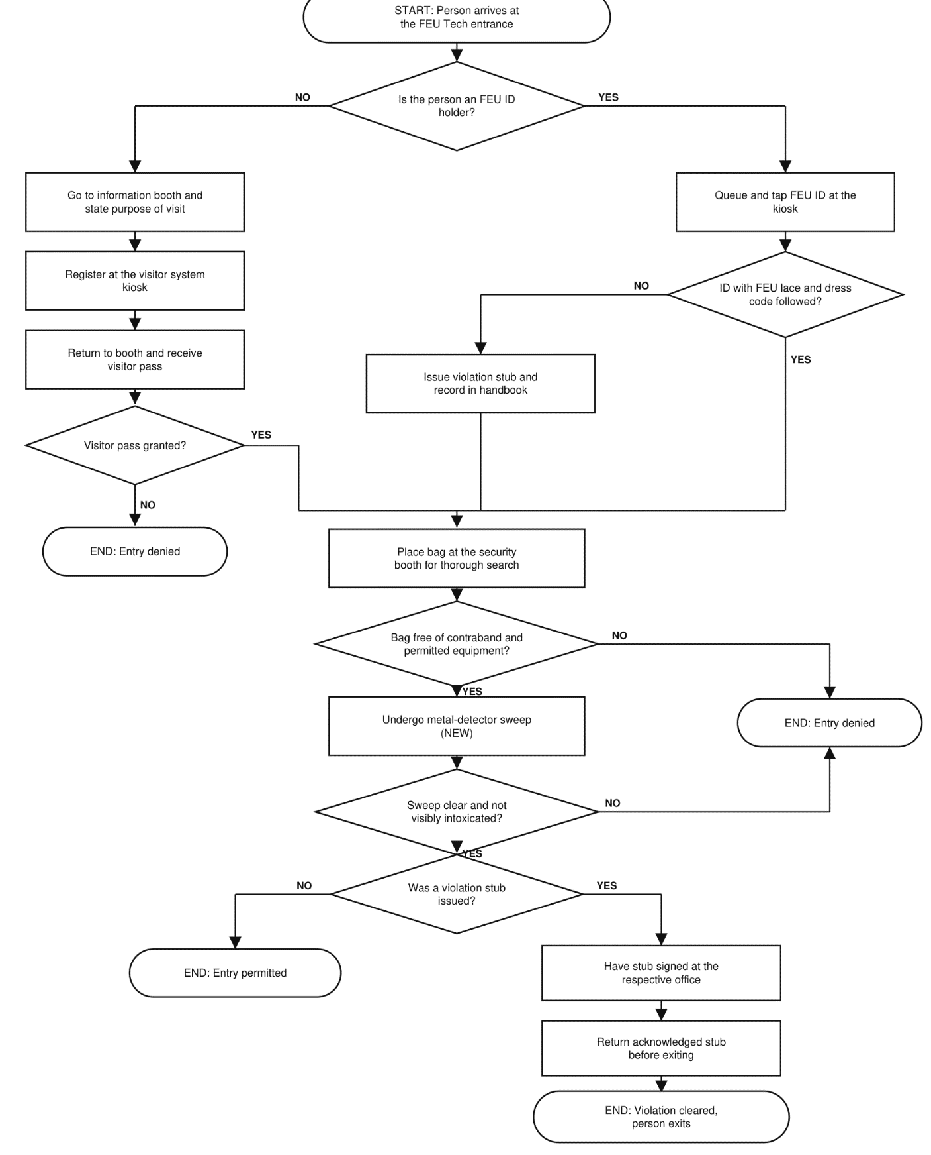

Part C - Explain the Model
Answer each question in two to four complete sentences.
- What is the purpose of your entry-policy model?
The purpose is to show, in one simplified diagram, how the school's new entry policy decides whether a person arriving at the gate is admitted, admitted with a violation recorded, or refused entry. It sets out the order of the checks and the conditions that send a person down one path rather than another, so the logic of the policy can be followed without watching the actual queue. It is a conceptual model for understanding and explanation, not a simulation that predicts waiting times.
- Why did you select the identified entities and attributes?
The entity is the person seeking entry, because that is the only thing that actually moves through the system from the queue to admission or refusal. Security guards, the ID kiosk and the visitor system were treated as resources rather than entities, since they stay in place and act on the person instead of flowing through the process. Students, instructors, employees and associates were kept as a single insider path because they follow the same procedure. The attributes chosen are only those that change the outcome: role, whether the FEU ID and lace are worn, dress-code compliance, contraband, equipment needing a permit, and sobriety.
- Is the system discrete or continuous? Explain.
The system is discrete. People arrive and are processed as separate, countable individuals, and the state of the system changes only at distinct events such as an ID being tapped, a bag being cleared, or a stub being issued. Nothing in the model changes between those events. A continuous system would be one whose state varies smoothly over time, such as water flowing through a pipe, which is not how an entrance gate behaves when each person is handled one at a time.
- Is the model deterministic or stochastic? Explain.
The model as drawn is deterministic, because a person's attributes fully determine their path and the same inputs always produce the same outcome, with no step depending on chance. That is a property of the model rather than of reality. The real entrance contains randomness, since arrival times, queue lengths and which bags receive closer attention all vary. Those elements were deliberately left out, so the model answers what happens to a given person rather than how long it takes. Adding arrival and service times drawn from probability distributions would make it stochastic.
- What assumptions did you make?
The checks are assumed to be applied consistently and correctly, so a guard never misses a violation and never records one wrongly. Every person is assumed to pass through the checks in the same fixed order, with no queue jumping. The dress code is treated as a single condition even though it has several parts, and the ordinary rule is assumed rather than the relaxed warm-season rule that allows shorts below the knee during the hotter months. Directors and associates are assumed to use the same gate as everyone else, since that is what happens most of the time. A dress-code or ID violation is assumed to be recorded rather than to stop entry, while contraband or a failed sweep stops it.
- What parts of the actual entry policy were simplified or excluded?
Time was excluded entirely, so queueing and how long each check takes are not represented even though they are the most visible part of the real experience. The dress code was compressed into one decision instead of separate checks for footwear, shorts and revealing clothing, and its seasonal variation was left out. Human judgement was removed, since in reality a guard decides how thoroughly to search a bag and whether a borderline outfit passes. The separate entrance used by directors and associates, through the elevator below, is excluded because it is the exception rather than the usual route. The visit to the respective office is shown as a single step, without its internal procedure.

- How does the new school entry policy differ from the previous policy? Identify any requirements or procedures that were added, removed, modified, or retained. Explain how these changes affect your model of the entry process.
The main change is an addition. Previously the only security check at the gate was the bag search; the metal-detector sweep is new. Nothing was removed, and the rest of the process was retained: the ID tap at the kiosk, the dress-code and ID requirements, the violation stub procedure for insiders, and the separate registration route for outsiders all continue as before. In the model this addition matters because it introduces a further activity and a further decision after the bag search, which creates a second way for a person to be denied entry at the security booth. Under the previous policy the same flowchart would end at the bag-search decision, so the new policy makes the path to admission longer and makes the denial outcome reachable from two separate conditions rather than one.

Important Reminders
  - Base the model on the official new entry policy rather than guesses or an AI-generated version of the policy.
  - Do not include names, identification numbers, photographs, or personal information of actual students or employees.
  - Do not photograph restricted areas, identification cards, security equipment, or security personnel.
  - Clearly distinguish an entity from its attributes.
  - Make sure every decision branch leads to another step or a final outcome.
  - This homework requires a conceptual model; programming and computer simulation are not required.

Submission Requirements
Submit one PDF file containing:
  - your name and section;
  - the title of the model;
  - the completed model-elements table;
  - the entry-policy flowchart;
  - answers to the questions;
  - the completed AI Declaration form (per member);
Suggested filename: surnames_hwk1.pdf

Rubric

Criterion | Excellent | Satisfactory | Needs Improvement | Pts
Model elements | All required elements are accurate, specific, and clearly distinguished. | Most elements are correct, with minor omissions or unclear descriptions. | Several elements are missing, confused, or incorrect. | 5
Policy accuracy | The model accurately represents the official policy and its important conditions. | The model generally represents the policy but contains minor omissions or inaccuracies. | The model contains major inaccuracies or is not based on the official policy. | 4
Flowchart logic | The sequence, symbols, branches, and outcomes are complete and logically correct. | The flowchart is understandable but has minor issues in its sequence, symbols, or branches. | The flowchart is incomplete, difficult to follow, or logically incorrect. | 5
Assumptions and limitations | Assumptions and exclusions are clearly identified and reasonably justified. | Assumptions and limitations are present but insufficiently explained. | Assumptions or limitations are missing or inappropriate. | 2
Analysis and explanation | Answers demonstrate clear understanding and use accurate modeling concepts. | Answers show basic understanding but contain minor misconceptions. | Answers are incomplete or show limited understanding. | 3
Presentation and completeness | The submission is complete, readable, labeled, and professionally presented. | The submission is complete but has minor presentation issues. | The submission is incomplete or difficult to read. | 1
TOTAL |  |  |  | 20

